**Course Specialist Year 12 Test Four 2022**

Student name: ________________ Teacher name: ________________

**Task type: Response**

**Time allowed for this task: _____40______ mins**

**Number of questions: _____6______**

**Materials required:** Upto 3Calculators with CAS capability (to be provided by the student)

Standard items: Pens (blue/black preferred), pencils (including coloured), sharpener, correction fluid/tape, eraser, ruler, highlighters

Special items: Drawing instruments, templates, No notes allowed  
A4 paper, and up to three calculators approved for use in the WACE examinations

**Marks available: __40____ marks**

**Task weighting: _10___%**

**Formula sheet provided: Yes**

**Note: All part questions worth more than 2 marks require working to obtain full marks.**

**No notes allowed**

**No notes allowed**

Q1 (5 marks) (4.1.6)

Determine the volume of the solid formed by rotating the area enclosed between  about the y axis, as shown below.

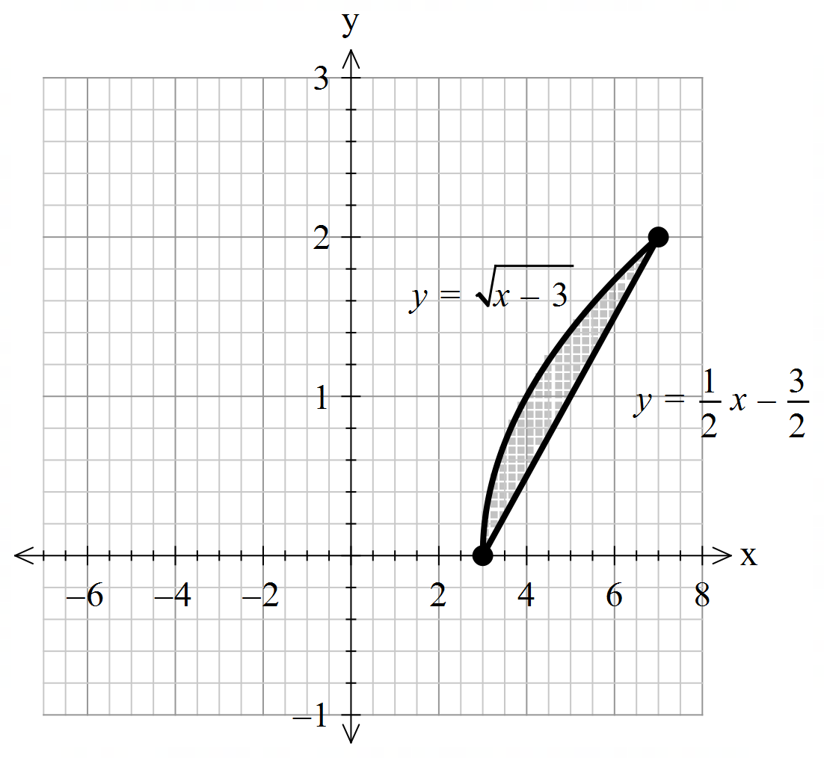

Q2 (5, 3 & 2= 10 marks) (4.1.4)

1. By using integration and partial fractions, show how to derive  from the differential equation () and  is a constant.

Q2 continued

1. Let  equal the number of kangaroos living in a habitat after  years and  .

If initially there are  kangaroos, determine the number in 10 years time.

1. Determine the size of the population at the maximum growth rate.

Q3 (3, 2 & 3 = 8 marks) (4.2.5)

1. Sketch the slope field on the axes below for 

1. Show the solution curve on the axes above that passes through point (2,2).
2. Determine in cartesian form the solution curve for b above **without using a classpad**.

Hint – use logarithmic differentiation. Show all working.

Q4 (5 marks) (4.2.1)

Determine expressions in terms of  only for  in terms of only, using the following equation 

Q5 (3 & 3 = 6 marks) (4.2.7)

Consider a particle that is moving with SHM such that  with a maximum speed of 12 m/s.

1. Determine the exact speed when the particle is half of an amplitude from the origin.
2. Determine the percentage of the time that the particle is more than half an amplitude from the centre.

Q6 (4 & 2 = 6 marks) (4.2.7)

The motion of a bullet through a wall is modelled by the equation  where  is its acceleration and  its velocity  seconds after impact. Initially at impact the speed is 300 m/s and is at the origin (metres)

1. Determine  in terms of  only.

Q6 continued-

1. Determine how far the bullet penetrates the wall before coming to rest to the nearest mm.